27 Hour Data Engineering Luke Bootcamp
Saturday, August 8, 2026
2:00 PM

Data Engineer Bootcamp (FREE 27+ Hour Course) - SQL, Python, Cloud, Bash, AI, Git & GitHub
Also check this one out: Databricks vs Snowflake vs Fabric: Which One Should You Learn?

  - Screenshots

  - Data Engineer = pipe your data into your analytical systems
  - 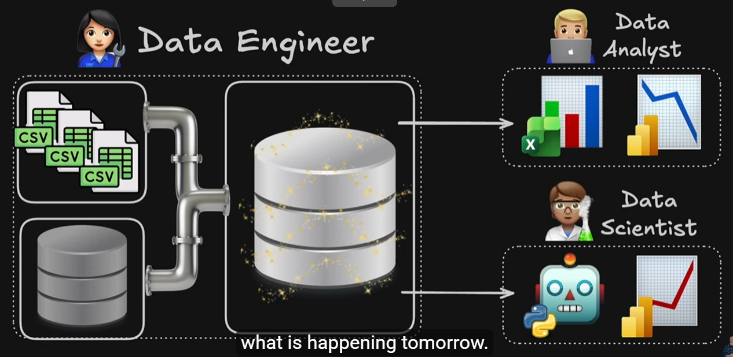

  - 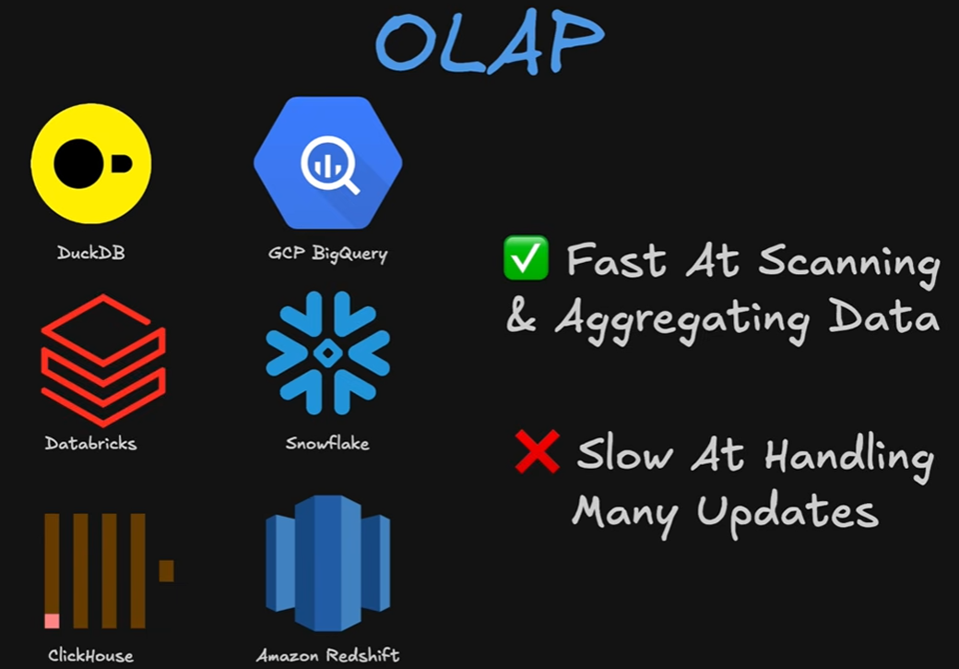

  - 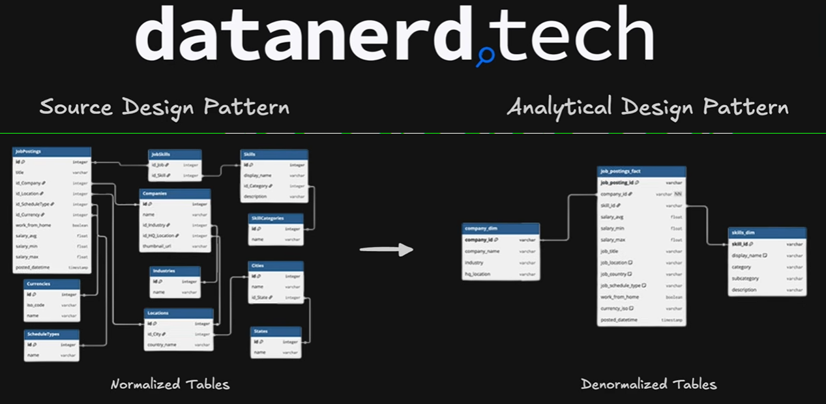
    - Star Schema
  - 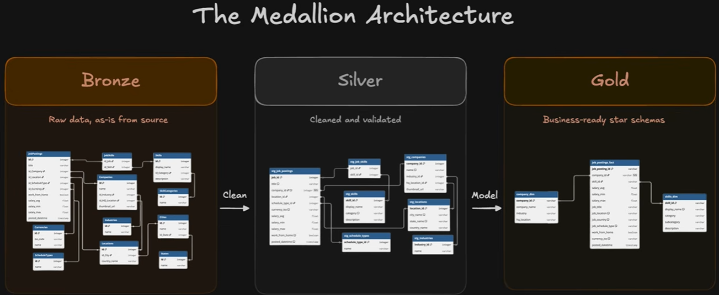

  - 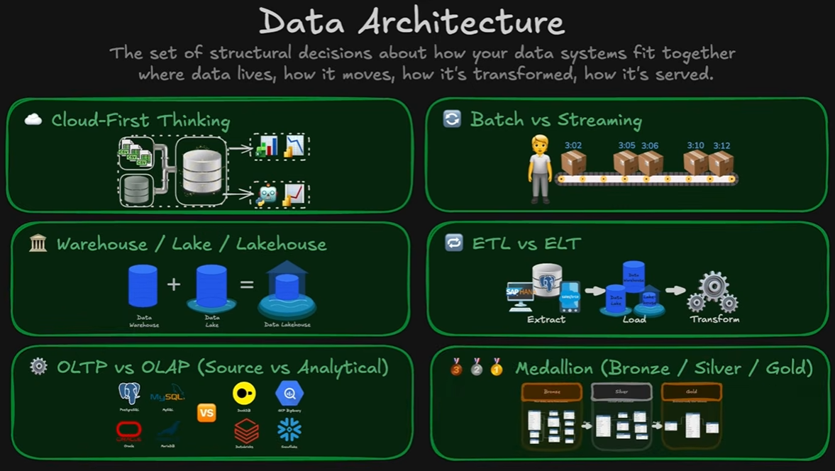
  - 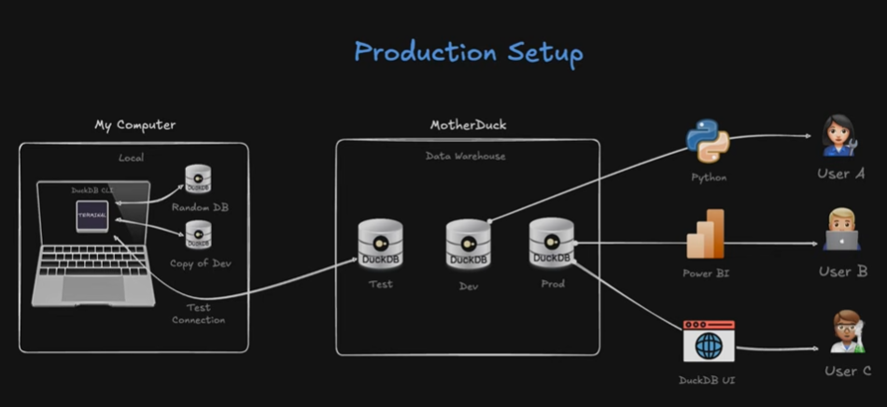
  - 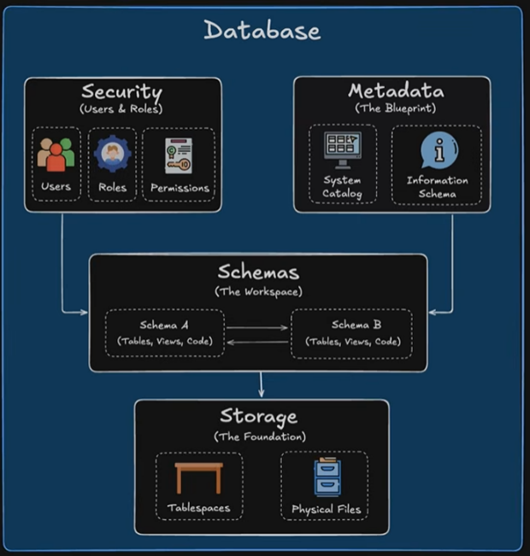
  - 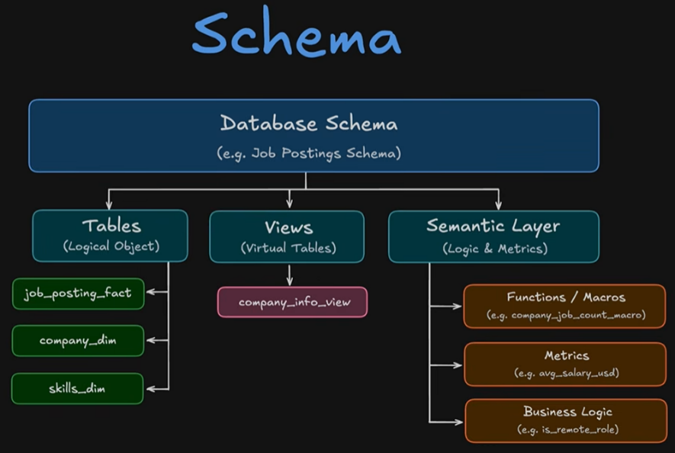
  - 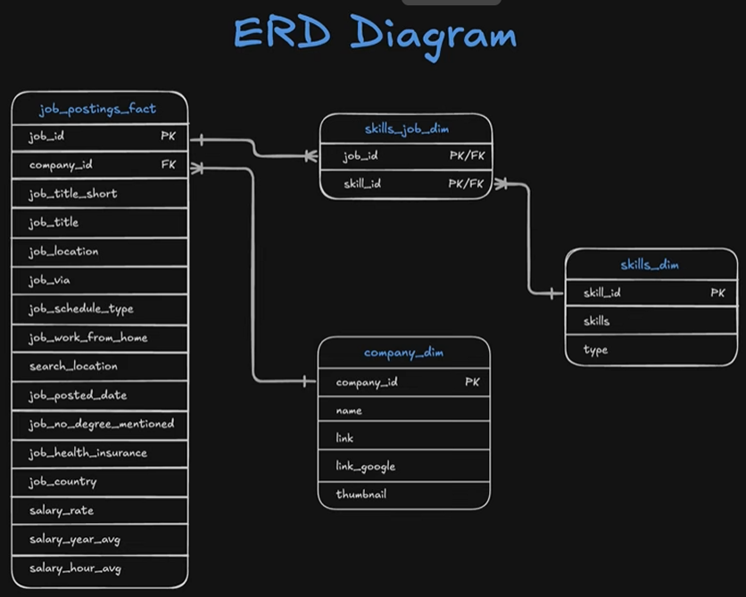
    - The 2 fields in the skills_job_dim table are called "Composite Primary Keys" because the combination of the two columns acts as a primary key (if you just used one of the columns by itself it would not be a unique primary key, you need both concatenated)`- meanwhile (and separate from the "Composite" topic) they are also foreign keys for the sake of their connection to the job_id and skill_id primary keys on the 2 connected tables

  - Part 1
    - Terminal
      - 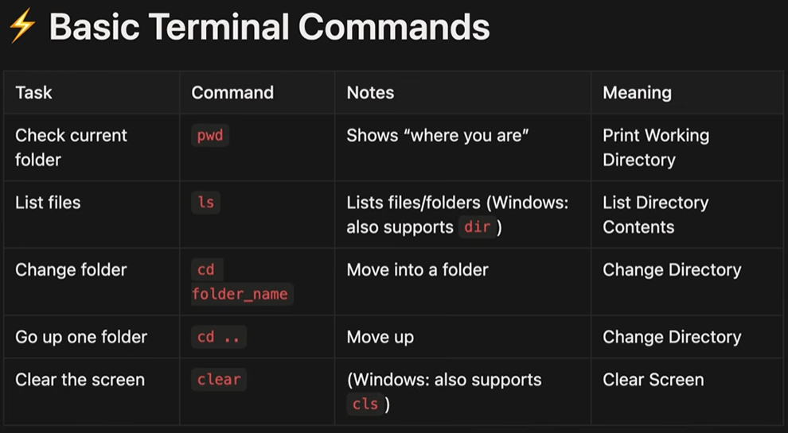

  - Code we ran to introduce us to terminal:

uia09337@CQL4137W MINGW64 ~/Desktop
$ echo "Data Analyst" > file1.txt

uia09337@CQL4137W MINGW64 ~/Desktop
$ cat file1.txt
Data Analyst

uia09337@CQL4137W MINGW64 ~/Desktop
$ echo "Data Nerdz" >> file1.txt

uia09337@CQL4137W MINGW64 ~/Desktop
$ cat file1.txt
Data Analyst
Data Nerdz

uia09337@CQL4137W MINGW64 ~/Desktop
$ head file1.txt
Data Analyst
Data Nerdz

uia09337@CQL4137W MINGW64 ~/Desktop
$ head -n 2 file1.txt
Data Analyst
Data Nerdz

uia09337@CQL4137W MINGW64 ~/Desktop
$ head -n 1 file1.txt
Data Analyst

uia09337@CQL4137W MINGW64 ~/Desktop
$ nano file1.txt

uia09337@CQL4137W MINGW64 ~/Desktop
$ cat file1.txt
Data Analyst
Data Nerdz
Data Scientist
Data Engineer

uia09337@CQL4137W MINGW64 ~/Desktop
$ man ls
bash: man: command not found

uia09337@CQL4137W MINGW64 ~/Desktop
$ ls --help

  - Metadata
    - Use information_schema - read only tables that house the data defining the database
    - 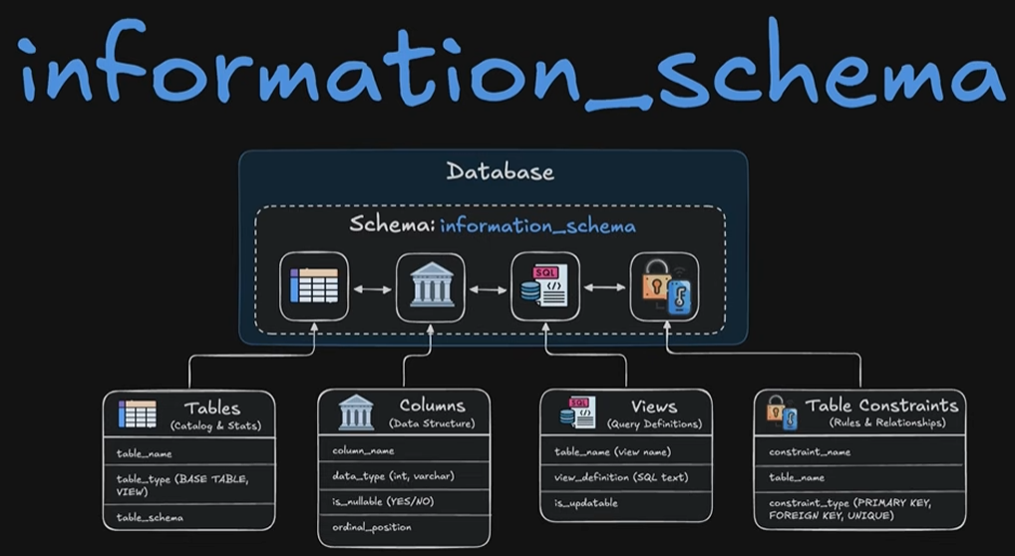

  - Order of Execution: Parser, Optimizer and Executor
Parser = checks your syntax
Optimizer = figures out most efficient way to run query, will even rewrite your query behind the scenes if necessary
Executor = runs optimized plan step by step. Reads your data, applies filters/joins, groups aggregates, then returns the necessary rows
Order to write:
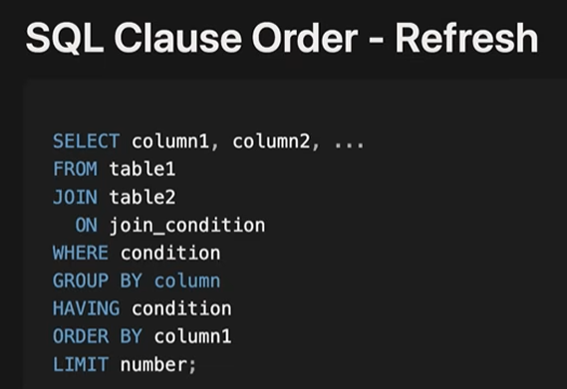
Order of operations:
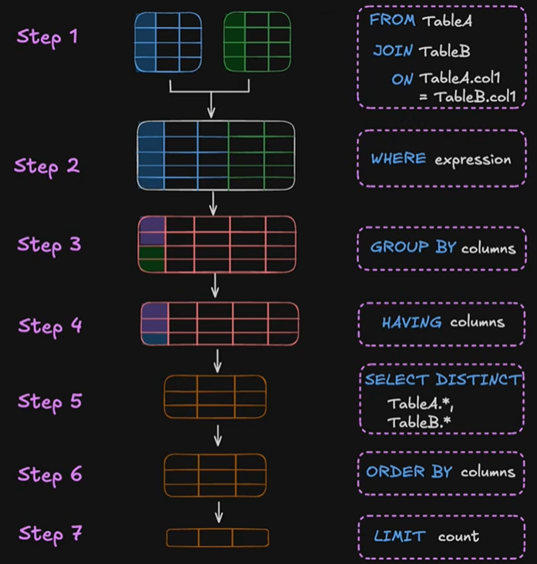
Reminder - Having is filtering/Where but for aggregates
Table name aliases can be used throughout because they occur in Step 1 of the order execution, but aliasing something like a column name cannot be references in a group by cause for example, and this is because of order execution. Group by occurs in Step 3 before the alias is defined for the column in Step 5
However you CAN use the column aliases in Order By, because it comes after Step 5! Just not in WHERE/Group By unfortunately

Explain - put in front of any query to explain the execution plan/order of operations. Does not actually execute the query, that's why you see "~" in front of every row count estimate
Explain analyze - same as above, but does actually execute all of the steps to give you exact row counts and run times
Read the output in VS Code from bottom to top!
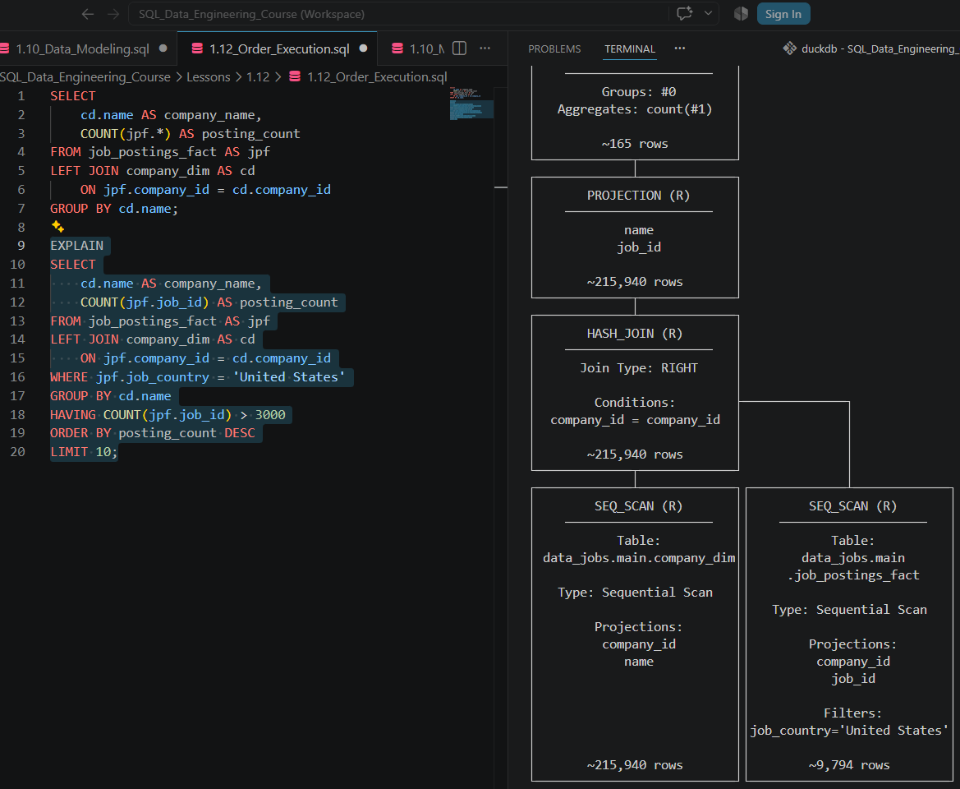

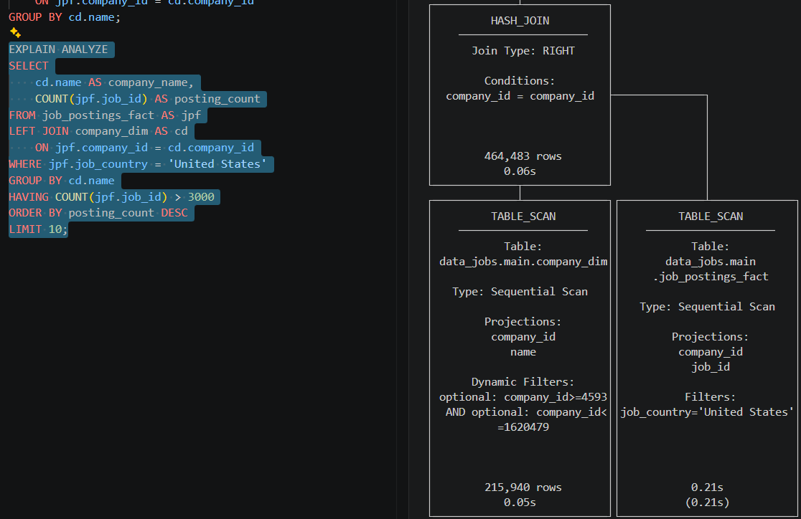

Markdown Cheat Sheet | Markdown Guide

